**Retail Sales Analysis SQL Project**

**Record Count**: Determine the total number of records in the dataset.

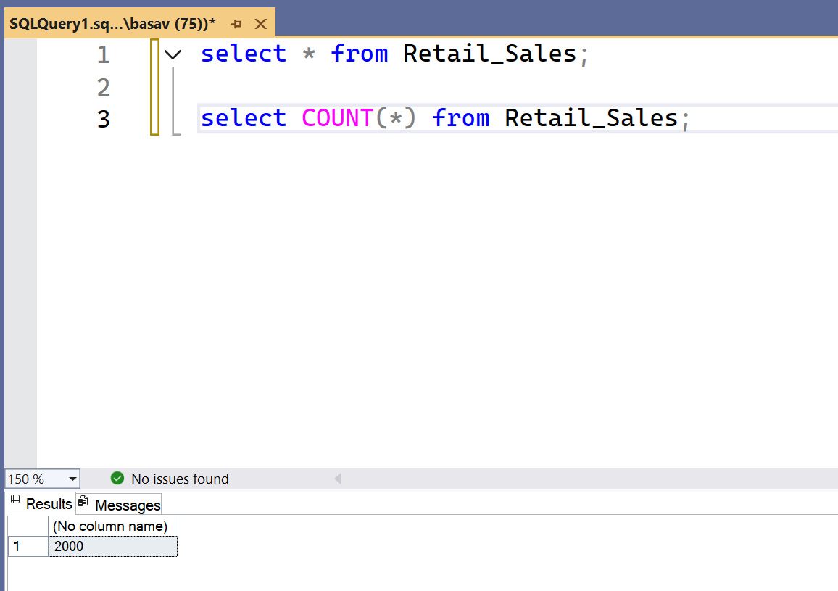

**Customer Count**: Find out how many unique customers are in the dataset.

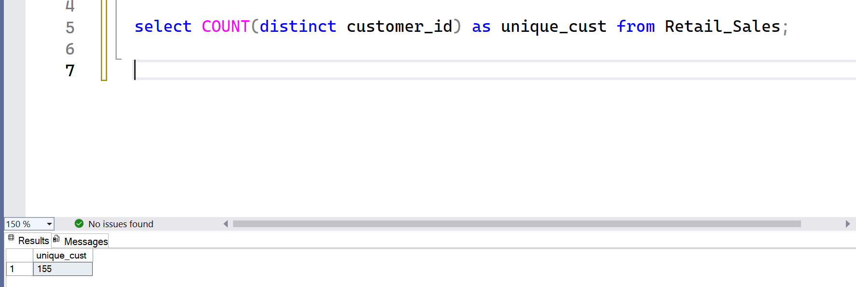

**Category Count**: Identify all unique product categories in the dataset.

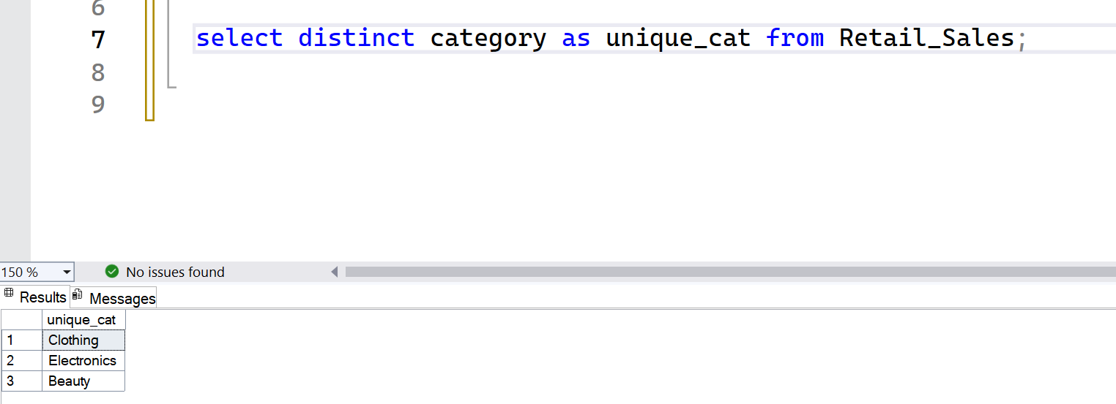

**Null Value Check**: Check for any null values in the dataset and delete records with missing data.

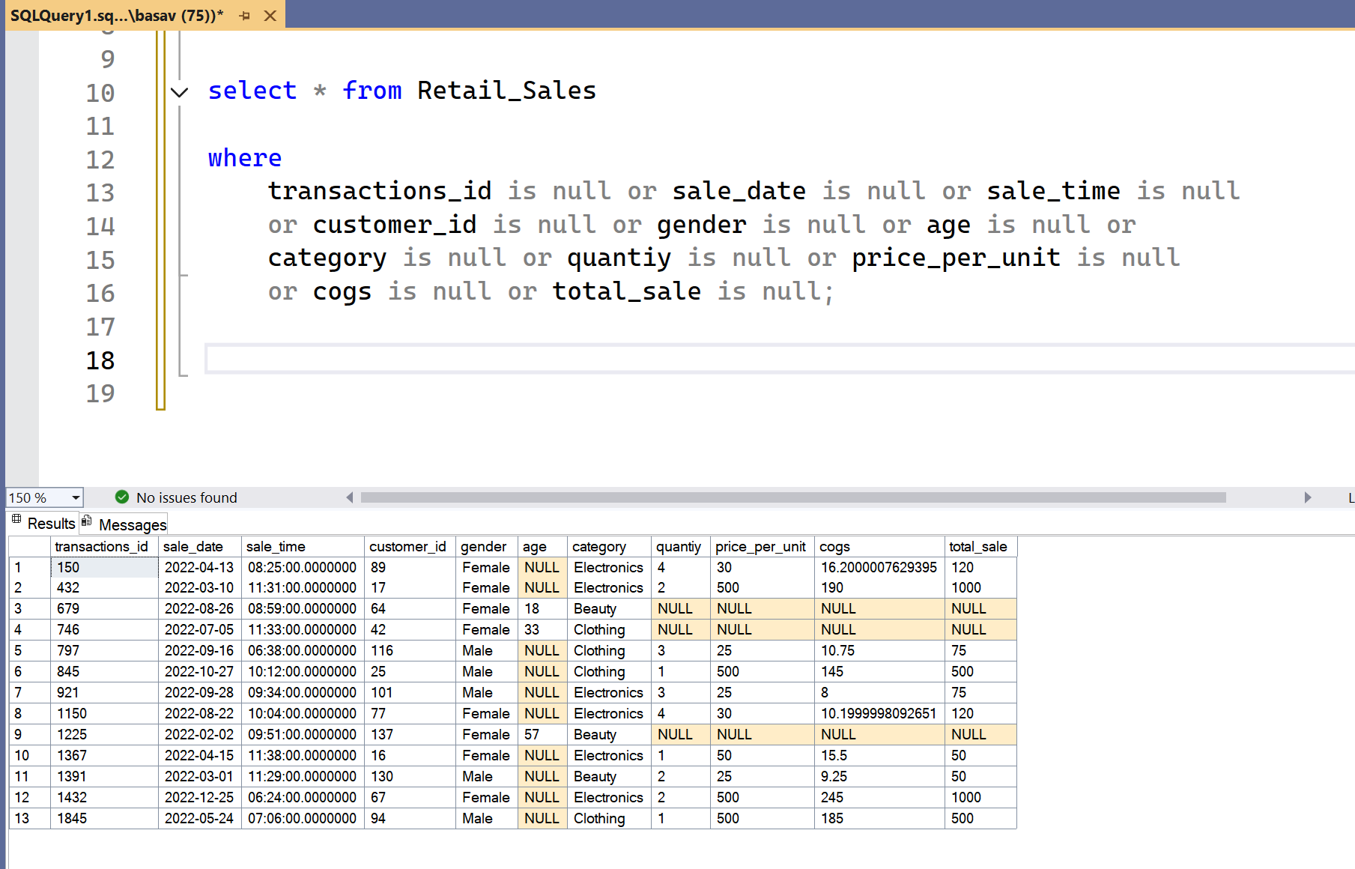

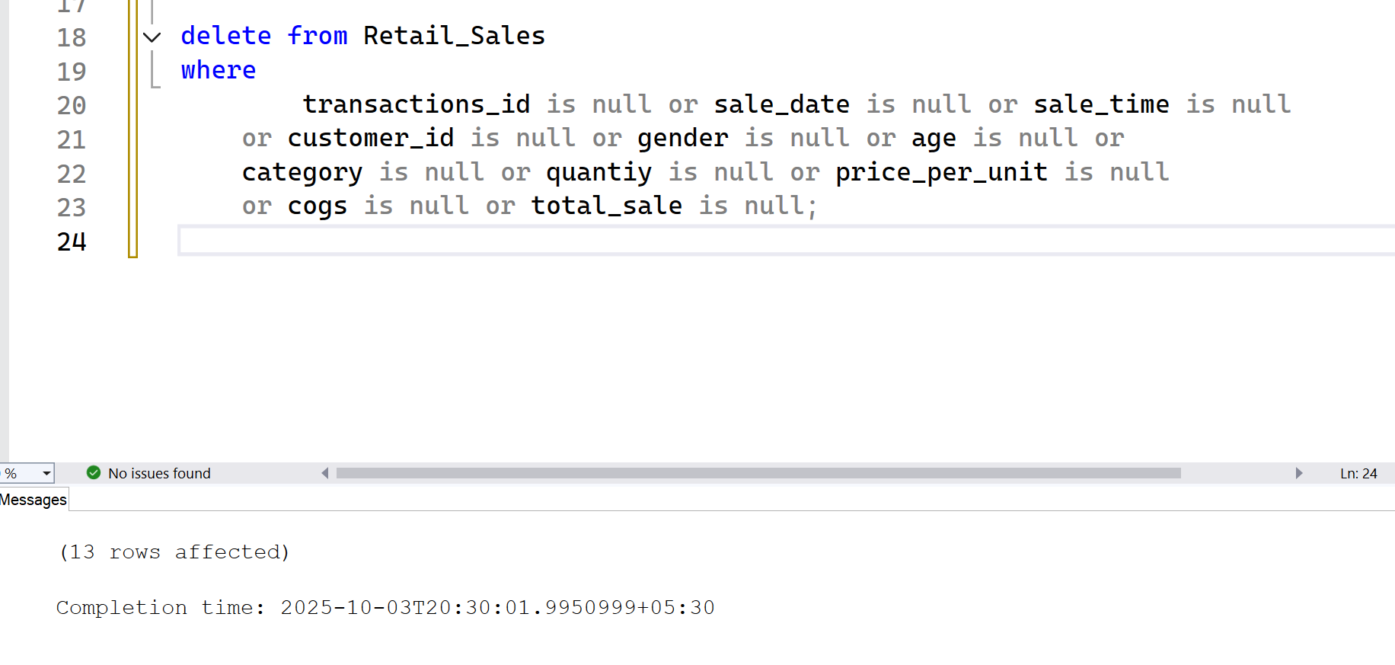

**Data Analysis & Findings**

**Write a SQL query to retrieve all columns for sales made on '2022-11-05**’

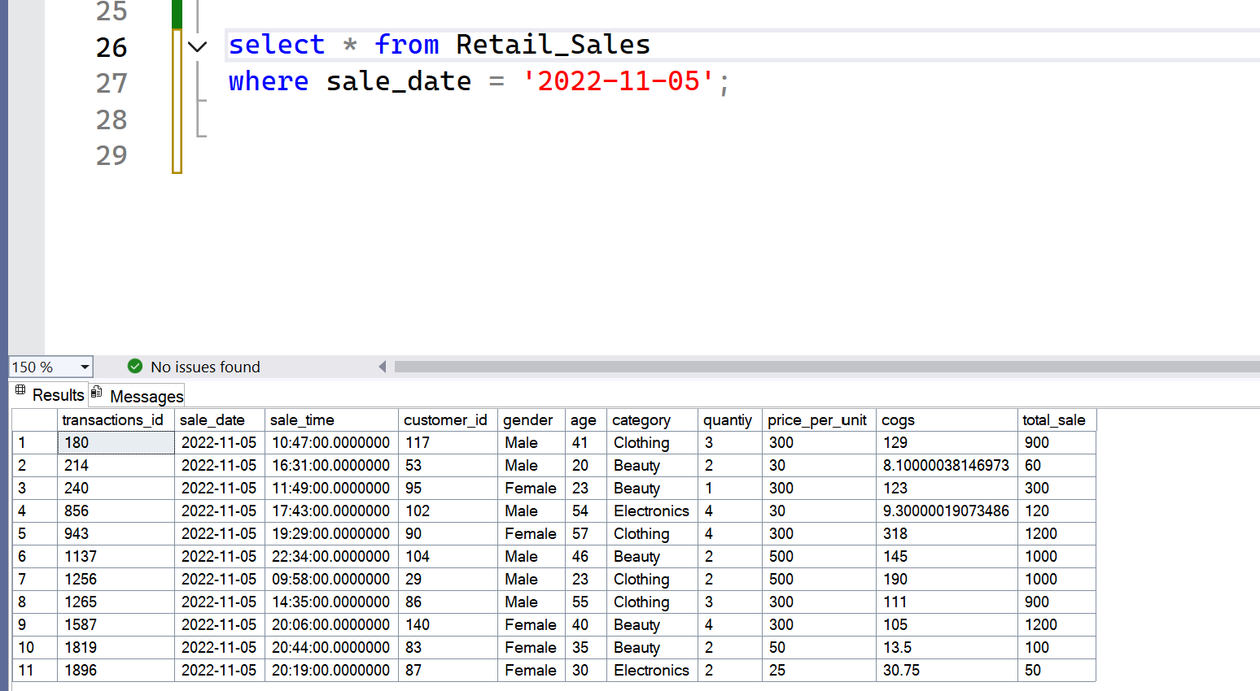

**Write a SQL query to retrieve all transactions where the category is 'Clothing' and the quantity sold is more than 4 in the month of Nov-2022**:

**Write a SQL query to calculate the total sales (total_sale) for each category.**:

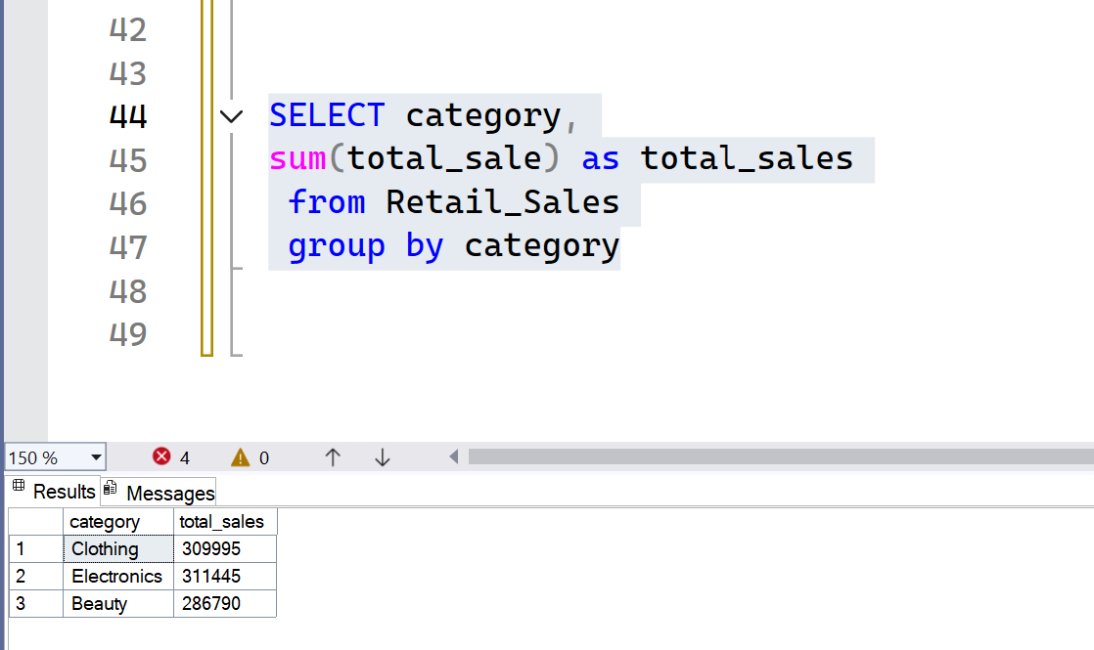

**Write a SQL query to find the average age of customers who purchased items from the 'Beauty' category.**:

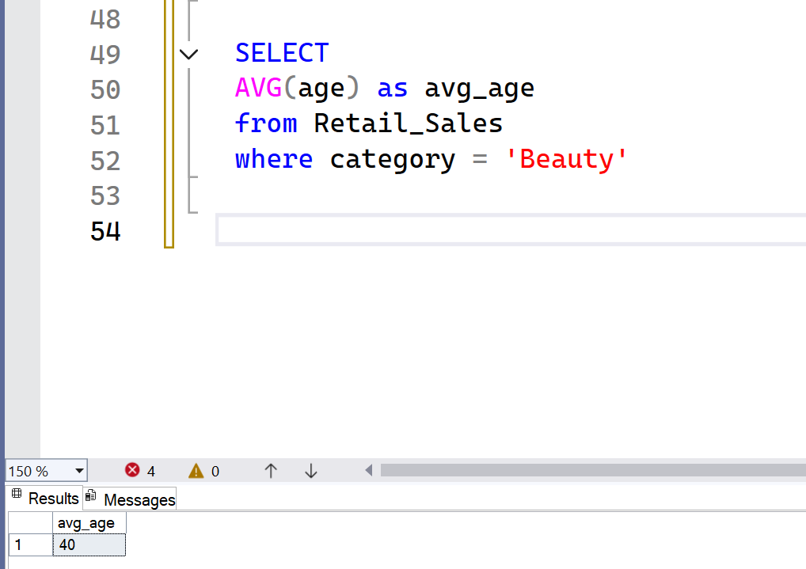

**Write a SQL query to find all transactions where the total_sale is greater than 1000.**:

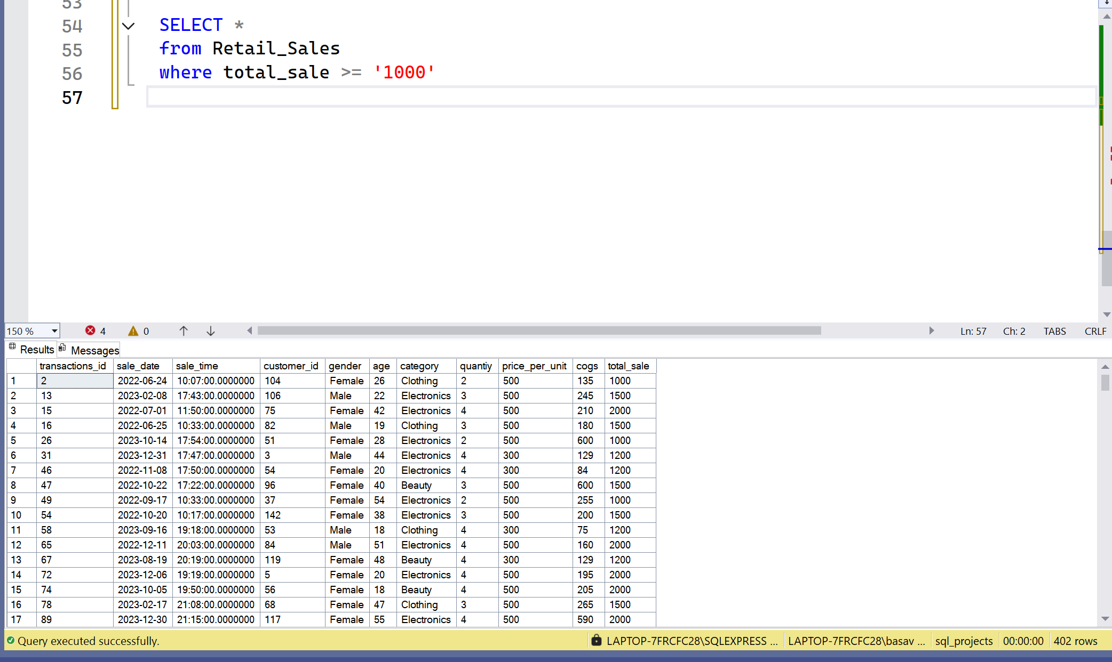

**Write a SQL query to find the total number of transactions (transaction_id) made by each gender in each category.**:

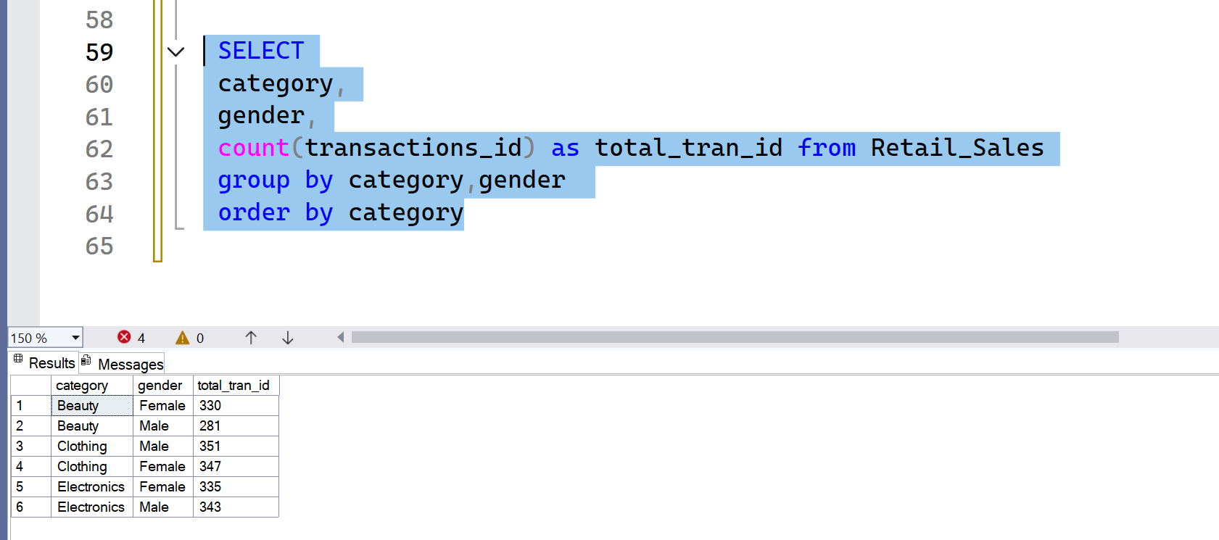

**Write a SQL query to calculate the average sale for each month. Find out bestselling month in each year**:

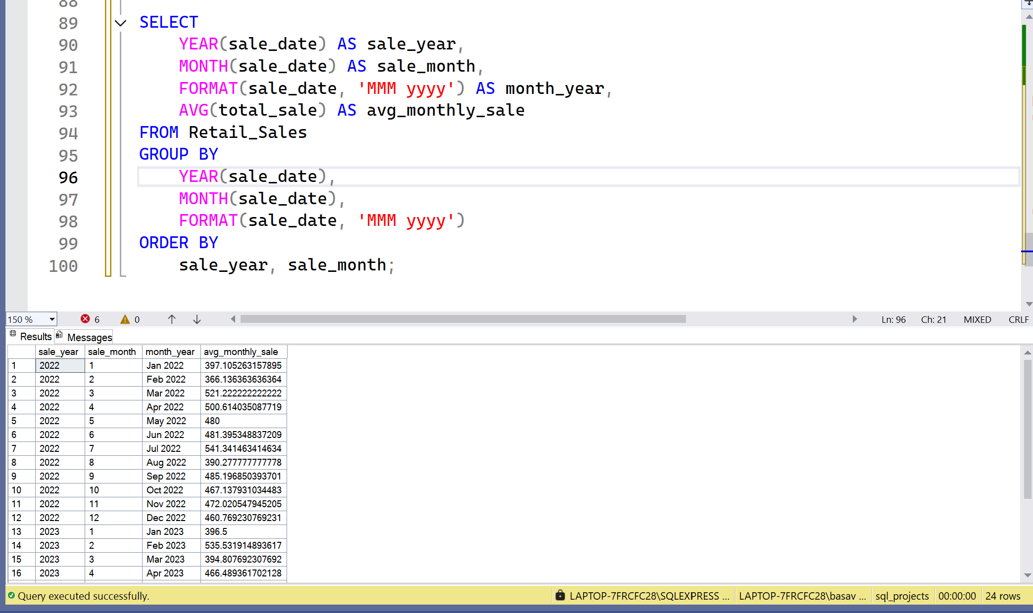

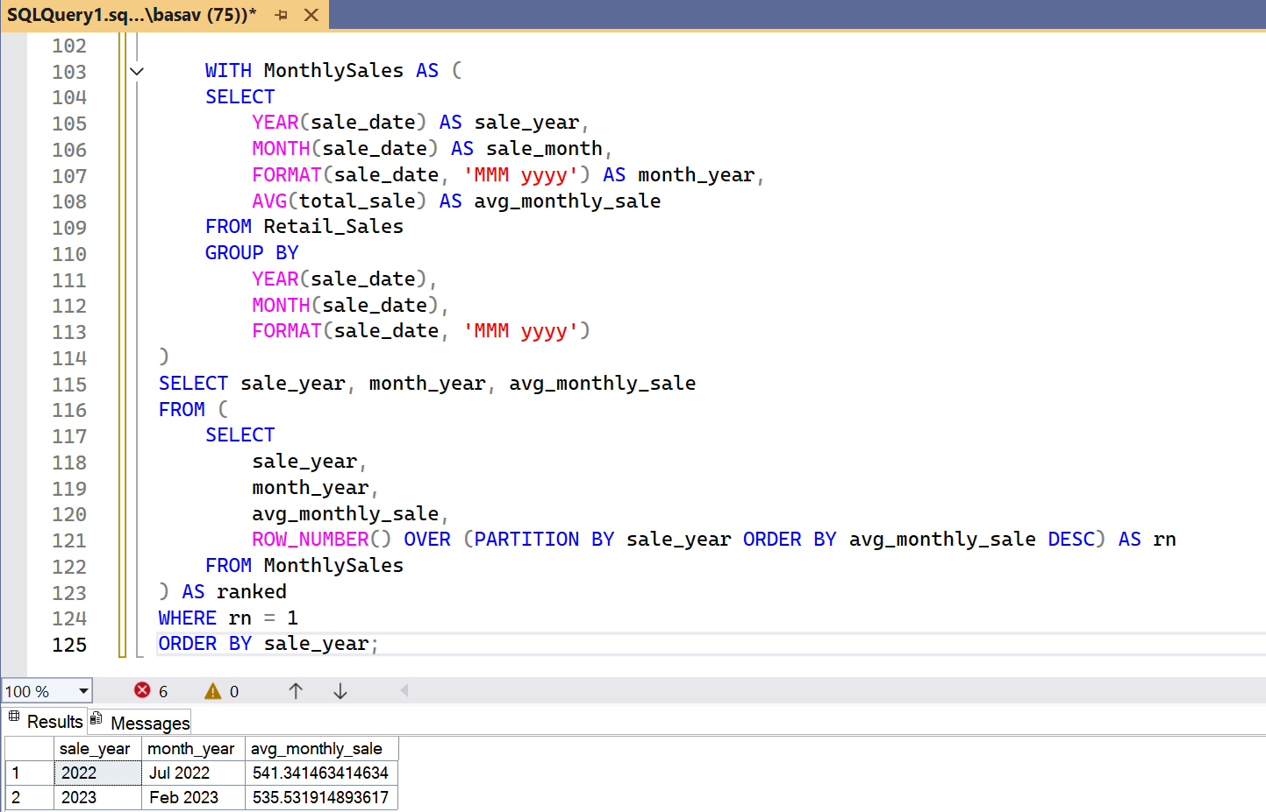

Write a SQL query to find the top 5 customers based on the highest total sales **:

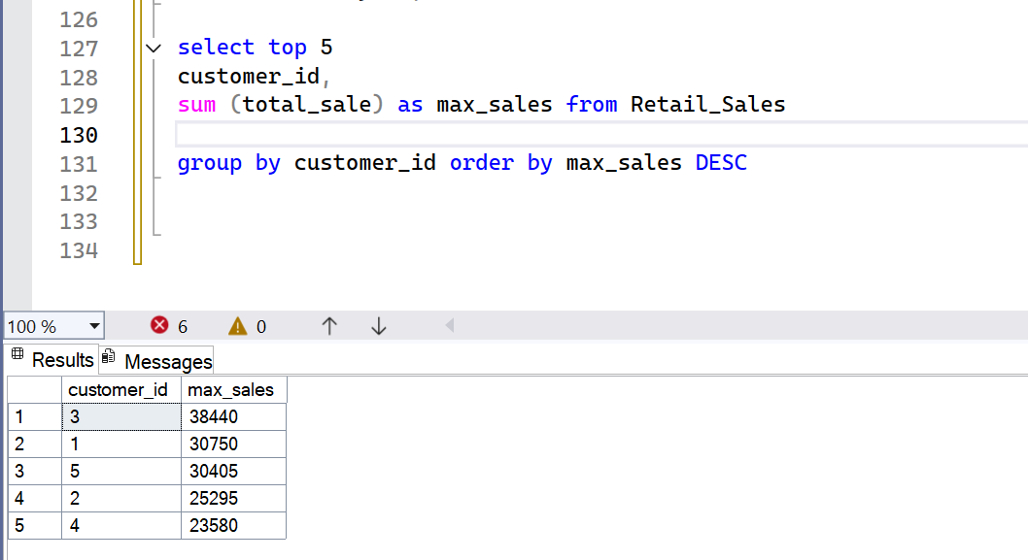

**Write a SQL query to find the number of unique customers who purchased items from each category.**:

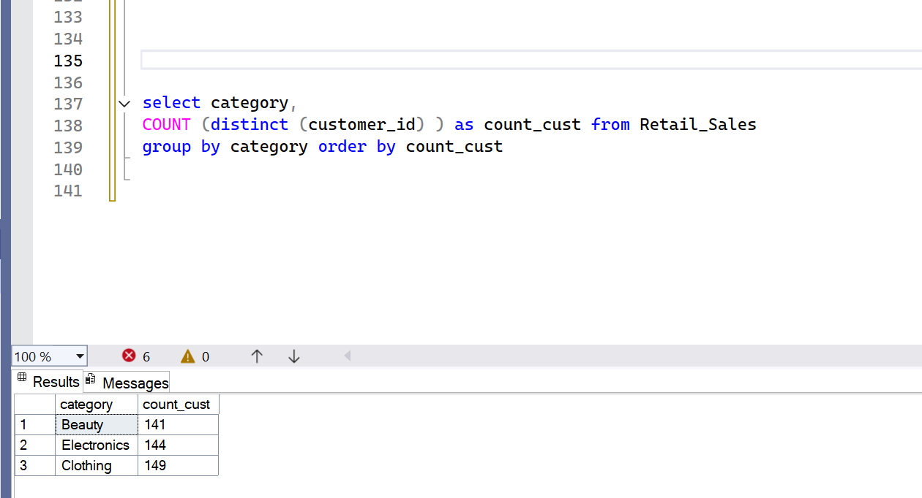

**Write a SQL query to create each shift and number of orders (Example Morning <12, Afternoon Between 12 & 17, Evening >17)**:

